**Homework 02**

**AA203: Optimal and learning-based Control**

Ricardo Luiz Moreira Paschoeto

[rp304154@stanford.edu](mailto:rp304154@stanford.edu)

**Problem 1:** Introduction to Q-learning

a) For learning rate = 0.2

Figure 1 - Q-values for state-actions

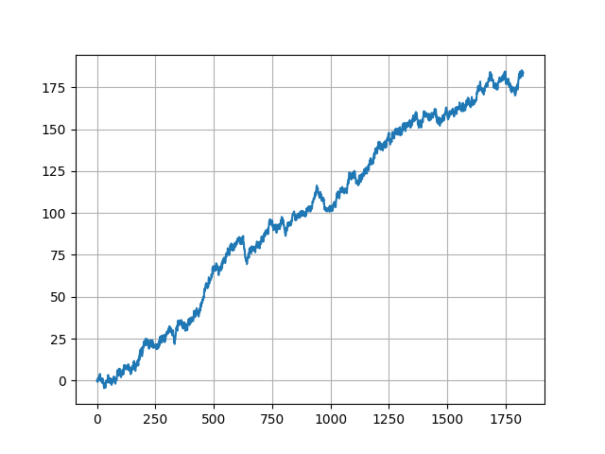

Figure 2 - Aggregate profit over 5 years.

Python code:

def policy(state, Q):

    return np.argmax(Q[state])*2

def e_greedy(state,Q):

    if np.random.random() < epsilon:

        a = random_policy()

        index = int(a/2)

        return random_policy(), index

    else:

        index = np.argmax(Q[state])

        a = index*2

        return a, index

def q_learning():

    q_values = np.zeros((len(sim.valid_states),len(sim.valid_actions)))

    for n in range(N):

        s = sim.reset()

        for t in range(len(data)):

            x0_hist.append(copy.deepcopy(q_values[0]))

            x1_hist.append(copy.deepcopy(q_values[1]))

            x2_hist.append(copy.deepcopy(q_values[2]))

            x3_hist.append(copy.deepcopy(q_values[3]))

            x4_hist.append(copy.deepcopy(q_values[4]))

            x5_hist.append(copy.deepcopy(q_values[5]))

            a, index = e_greedy(s,q_values)

            sp,r = sim.step(a)

            td = r + gamma*np.max(q_values[sp]) - q_values[s,index]

            q_values[s,index] += alpha*td

            s = sp

    return q_values

def simulation(Q):

    s = sim.reset()

    r_hist.append(0)

    for t in range(T):

        a = policy(s,Q)

        sp, r = sim.step(a)

        r_hist.append(r)

        s = sp

b) Result for *Q* from Iteration Values Iteration along 5 years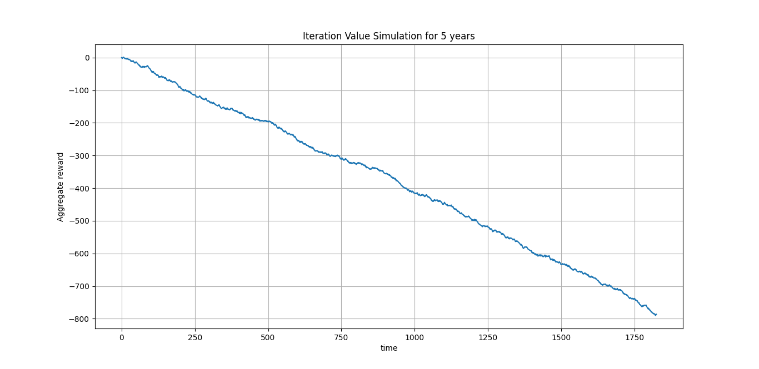

Figure - Simulation over 5 years

Python code:

iteration = 0

def value_iteration(sim, epsilon=0.001):

    V = np.zeros((len(sim.valid_states)))

    q_values = np.zeros((len(sim.valid_states),len(sim.valid_actions)))

    def next_step(V, x):

        nv = 0

        policy = 0

        for a in sim.valid_actions:

            for d, prob in enumerate(sim.demand_probs):

                next_state = sim.transition(x,a, d)

                r = sim.get_reward(x, a, d)

                v = sim.demand_probs[next_state] * (r + gamma * V[next_state])

                if nv < v:

                    nv = v

                    policy = a

        return nv, policy

    while True:

        delta = 0

        for x in sim.valid_states:

            prev_v = V[x]

            best_v, best_a = next_step(V, x)

            V[x] = best_v

            delta = max(delta, np.abs(prev_v - V[x]))

            q_values[x][int(best_a/2)] = V[x]

        print(delta)

        if delta < epsilon:

            break

    return q_values

c) Q-learning presented better results.

After read explanations about this behavior, where the Q-learning perform better than value iteration, my conclusion is how each algorithm works, Q-learning operate over a finite-horizon of five years while the Value Iteration operate over a infinite horizon. One of solutions to help us analyze this outperformance is doing the simulation with bigger values of gamma, forcing the VI policy cares about rewards in distant future. Q-learning already have this behavior, it cares about future reward.

**Problem 2:** Cart-pole swing-up

**a)** *A, B = jax.jacfwd(f, (0, 1))(s, u)*

**,b)**

$cost= \frac{1}{2}{\left(s_{N}-s^{*}\right)}^{T}Q_{N}\left(s_{N}-s^{*}\right)+ \frac{1}{2}\sum_{k=0}^{N-1}{({\left(s_{k}-s^{*}\right)}^{T}Q\left(s_{k}-s^{*}\right)+ u_{k}^{T}Ru_{k})}$ (I)

$∆s_{N}=s_{N}-s_{N}^{-}$ => $s_{N}=∆s_{N}+s_{N}^{-}$ (II)

$∆s_{k}=s_{k}-s_{k}^{-}$, => $s_{k}=∆s_{k}+s_{k}^{-}$ (III)

$∆u_{k}=u_{k}-u_{k}^{-}$. => $u_{k}=∆u_{k}+u_{k}^{-}$ (IV)

Substituting (II),(III) and (IV) in (I)

$$cost= \frac{1}{2}{\left(∆s_{N}+s_{N}^{-}-s^{*}\right)}^{T}Q_{N}\left(∆s_{N}+s_{N}^{-}-s^{*}\right)+\frac{1}{2}\sum_{k=0}^{N-1}{({\left(∆s_{k}+s_{k}^{-}-s^{*}\right)}^{T}Q\left(∆s_{k}+s_{k}^{-}-s^{*}\right)+{(∆u_{k}+u_{k}^{-})}^{T}R(∆u_{k}+u_{k}^{-}))}$$

Manipulating and considering *R, Q and $Q_{N}$*  are symmetric,

$$c\left(∆s_{k},∆u_{k}\right)=c_{k}+c_{N}+\frac{1}{2}{∆s}_{k}^{T}Q_{k}∆s_{k}+\frac{1}{2}∆u_{k}^{T}R_{k}∆u_{k}+\frac{1}{2}∆s_{N}^{T}Q_{N}∆s_{N}+q_{k}^{T}∆s_{k}+q_{N}^{T}∆s_{N}+r_{k}^{T}∆u_{k}$$

where,

$$c_{k}=\frac{1}{2}{\left(s_{k}^{-}-s^{*}\right)}^{T}Q_{k}\left(s_{k}^{-}-s^{*}\right)+\frac{1}{2}u_{k}^{-T}R_{k}u_{k}^{-},$$

$$c_{N}=\frac{1}{2}{\left(s_{N}^{-}-s^{*}\right)}^{T}Q_{N}\left(s_{N}^{-}-s^{*}\right),$$

And the terms,

$$q_{N}^{T}={\left(s_{N}^{-}-s^{*}\right)}^{T}Q_{N},$$

$$q_{k}^{T}={\left(s_{k}^{-}-s^{*}\right)}^{T}Q,$$

$r_{k}^{T}=u_{k}^{-T}R$.

c) Python code:

    def costs():

        c = np.zeros((N,m)) # immediate state cost

        cs = np.zeros((N, n)) # dc / dx

        cu = np.zeros((N, m)) # dc / du

        cuu = np.zeros((N, m, m)) # d^2 c / du^2

        css = np.zeros((N, n, n)) # d^2 c / dx^2

        cus = np.zeros((N, m, n))  # d^2 c / du / dx == 0 Don't have cross terms (s,u)

        for k in range(N-1):

            qkT = np.dot((s[k] - s_goal).T, Q) # (sk_bar - s_goal).T*Q

            rkT = u[k] @ R # uk.T*R

            c[k] = (0.5)*np.dot((s[k] - s_goal).T, np.dot(Q, (s[k] - s_goal))) + (0.5)*np.dot(u[k].T, np.dot(R, u[k])) # (1/2)*(sk_bar - s_star).T * Qk * (sk_bar - s_star) + (1/2)*(uk_bar.T * Rk * uk_bar)

            cs[k] = qkT # qk.T

            cu[k] = rkT # rk.T

            cuu[k] = np.array(R) # just R

            css[k] = np.array(Q) # just Q

        qNT = (s[-1] - s_goal).T @ Qf # (sN_bar - s_star).T*Qf

        c[-1] = (0.5)*(s[-1] - s_goal).T @ Qf @ (s[-1] - s_goal)  # (1/2)*(sN_bar - s_goal).T*QN*(sN_bar - s_goal)

        cs[-1] = qNT # qN.T ????

        css[-1] = Qf # final cost

        return np.array(c), np.array(cs), np.array(cu), np.array(cuu), np.array(css), cus

    # iLQR loop

    for _ in range(max_iters):

        # Linearize the dynamics at each step `k` of `(s_bar, u_bar)`

        A, B = jax.vmap(linearize, in_axes=(None, 0, 0))(f, s[:-1], u)

        A, B = np.array(A), np.array(B)

        # WRITE YOUR CODE BELOW ###############################################

        # Update the arrays `L`, `l`, `s`, and `u`.

        # for storing quadratized cost function

        # Foward pass:

        for k in range(N):

            s[k + 1] = f(s[k], u[k])

        # Compute cost

        c, cs, cu, cuu, css, cus = costs()

        # Backward pass:

        v, v_bold, V = c[-1].copy(), cs[-1].copy(), css[-1]

        l = np.zeros((N, m))

        L = np.zeros((N, m, n))

        for k in range(N - 1, -1, -1):

            Qk = c[k] + v

            Qs = cs[k] + (A[k].T @ v_bold)

            Qu = cu[k] + (B[k].T @ v_bold)

            Qss = css[k] + (A[k].T @ V @ A[k])

            Quu = cuu[k] + (B[k].T @ V @ B[k])

            Qus = cus[k] + (B[k].T @ V @ A[k])

            l[k] = -np.linalg.inv(Quu) @ Qu

            L[k] = -np.linalg.inv(Quu) @ Qus

            v = Qk - 0.5*(l[k].T @ Quu @ l[k])

            v_bold = Qs - (L[k].T @ Quu @ l[k])

            V = Qss - (L[k].T @ Quu @ L[k])

        for k in range(N - 1):

            u[k] = u_bar[k] + l[k] + np.dot(L[k], s[k] - s_bar[k])

            s[k + 1] = f(s[k], u[k])

        #######################################################################

        print(np.max(np.abs(u - u_bar)))

        if np.max(np.abs(u - u_bar)) < eps:

            converged = True

            break

        else:

            u_bar[:] = u

            s_bar[:] = s

    if not converged:

        raise RuntimeError('iLQR did not converge!')

    return s_bar, u_bar, L, l

d) Python code:

        if simulate_continuous_time_dynamics:

            # WRITE YOUR CODE BELOW ###########################################

            # Update `u[k]` using the final LQR policy `L`, `l` output by

            # `ilqr` above to track the planned trajectory when we simulate the

            # continuous-time dynamics.

            u[k] = u_bar[k] + l[k] + np.dot(L[k], s[k] - s_bar[k])

            ###################################################################

            s[k+1] = odeint(lambda s, t: f(s, u[k]), s[k], t[k:k+2])[1]

e) Plot Results:

Figure 4 - Results for cart-pole iLQR

**Problem 3:** Cart-pole swing-up with limited actuation

a) the discrete dynamic is,

$$s_{k+1}=s_{k}+∆tf\left(s_{k}^{-},u_{k}^{-}\right),$$

Linearing around $\left(s_{k}^{-},u_{k}^{-}\right),$

$$s_{k+1}=\left(s_{k}^{-}+∆tf\left(s_{k}^{-},u_{k}^{-}\right)\right)+\left(I_{n}+∆t\frac{∂f}{∂s}\left(s_{k}^{-},u_{k}^{-}\right)\right)+\left(0+ ∆t\frac{∂f}{∂u}\left(s_{k}^{-},u_{k}^{-}\right)\right),$$

Where,

$$c_{k}=s_{k}^{-}+∆tf\left(s_{k}^{-},u_{k}^{-}\right),$$

$$A_{k}=\left(I_{n}+∆t\frac{∂f}{∂s}\left(s_{k}^{-},u_{k}^{-}\right)\right),$$

$B_{k}=\left(∆t\frac{∂f}{∂u}\left(s_{k}^{-},u_{k}^{-}\right)\right)$.

${(DLOCP)}_{k+1}$,

$$\min_{\left(s_{i},u_{i}\right)}\sum_{i=0}^{N-1}{dt}(\frac{1}{2}{\left(s_{N}-s^{*}\right)}^{T}Q_{N}\left(s_{N}-s^{*}\right)+ \frac{1}{2}\sum_{k=0}^{N-1}{({\left(s_{k}-\overline{s}\right)}^{T}Q\left(s_{k}-\overline{s}\right)+ u_{k}^{-T}Ru_{k}^{-})})$$

Subject to

$s_{i+1}=c_{i}+A_{i}\left(s_{i}-{\overline{s}}_{i}\right)+B_{i}\left(u_{i}-{\overline{u}}_{i}\right),i=0, … , N-1$

$$u_{lB}≤u_{i} ≤ u_{uB}, i=0, …, N-1$$

$${||s_{t}-\overline{s} ||}_{∞}≤ ρ$$

$${||u_{t}-\overline{u} ||}_{∞}≤ ρ$$

$$s\left(0\right)=s_{0},i=0$$

$s_{N}=s_{f},i=N$.

b) *A, B, c = jax.jacfwd(lambda x:f(x, u))(x), jax.jacfwd(lambda u:f(x, u))(u), f(x, u).*

c)Python code:

def scp_iteration(f,Q,R,Q_N,s_bar,u_bar,s_star,s0,N,dt,rho,uLB,uUB):

    ###########################################################################

    # WRITE YOUR CODE HERE

    # implement one iteration of scp

    # HINT: See slides 34-38 of Recitation 1.

    n = Q.shape[0]

    m = R.shape[0]

    S = {}

    U = {}

    u = np.zeros((N, m))

    s = np.zeros((N+1, n))

    #print("s shape = " + str(s.shape))

    cost_terms = []

    constraints = []

    #A, B, c = linearize(f, s_bar, u_bar)

    for t in range(N):

        S[t] = cvx.Variable(n)

        U[t] = cvx.Variable(m)

        cost_terms.append(cvx.quad_form(S[t] - s_star, Q)) # State cost

        cost_terms.append(cvx.quad_form(U[t], R)) # Control cost

        constraints.append(U[t] <= uUB)

        constraints.append(U[t] >= uLB)

        constraints.append(cvx.norm(U[t] - u_bar[t], "inf") <= rho) # Box constraint 1

        constraints.append(cvx.norm(S[t] - s_bar[t], "inf") <= rho) # Box constraint 2

        if t == 0: # S[0] == s0 # Initial condition

            constraints.append(S[t] == s0)

        if t > 0:

           A, B, c = linearize(f, s_bar[t - 1], u_bar[t - 1])

           constraints.append(A @ (S[t - 1] - s_bar[t - 1]) + B @ (U[t - 1] - u_bar[t - 1]) + c == S[t])

    S[t + 1] = cvx.Variable(n)

    A, B, c = linearize(f, s_bar[t], u_bar[t])

    constraints.append(A @ (S[t] - s_bar[t]) + B @ (U[t] - u_bar[t]) + c == S[t+1])

    cost_terms.append(cvx.quad_form(S[t + 1] - s_star, Q_N))

    obj = cvx.Minimize(cvx.sum(cost_terms))

    problem = cvx.Problem(obj, constraints)

    problem.solve()

    for k in range(len(U)):

       u[k, :] = U[k].value

    for t in range(len(S)):

       s[t, :] = S[t].value

    ###########################################################################

    return s,u

d)

Figure 5 - Results for cart-pole scp.